­



Politecnico di Milano

A.A. 2015-2016

Software Engineering 2: “MyTaxi”

Code inspection

Manzi Giuseppe (mat. 854470) &

Nicolini Alessandro (mat. 858858)

CONTENTS

1. Introduction 4

1.1 Revision History 4

1.2 Purpose and Scope 4

1.3 List of Reference Document 4

2. Integration Strategy 4

2.1 Entry Criteria 4

2.2 Element to be Integrated 4

2.3 Integration Testing Strategy 5

2.4 Sequence of Component 5

2.4.1 Software Integration Sequence 6

3. Individual Steps and Test Description 7

3.1 Integration test case I1 7

3.2 Integration test case I2 7

3.3 Integration test case I3 7

3.4 Integration test case I4 8

3.5 Integration test case I5 8

3.6 Integration test case I6 8

3.7 Integration test case I7 9

3.8 Integration test case I8 9

4. Tools and Test Equipment Required 10

5. Program Stubs and Test Data Required 10

# 1. Introduction

## 1.1 Revision History

## 1.2 Purpose and Scope

The Test Plan Document of MyTaxiService describe which test the development team have to do, in which sequence, which tools are used for testing (if any), which stubs/ drivers need to be developed.

## 1.3 List of Reference Document

* **“My taxi” RASD** (authors: *Giuseppe Manzi, Alessandro Nicolini*);
* **“My taxi” DD** (authors: *Giuseppe Manzi, Alessandro Nicolini*);
* **Integration test plan assignment** (authors: *Raffaela Mirandola*).

# 2. Integration Strategy

## 2.1 Entry Criteria

The first assumption to take is that, at the end of the document, all the Element that we describe in the Design Document must be integrated and tested.

To reach this goal we assume that all the document such as the Design Document and RASD are complete and all the classic Integration Fault are take in consideration before the start of the integration document.

## 2.2 Element to be Integrated

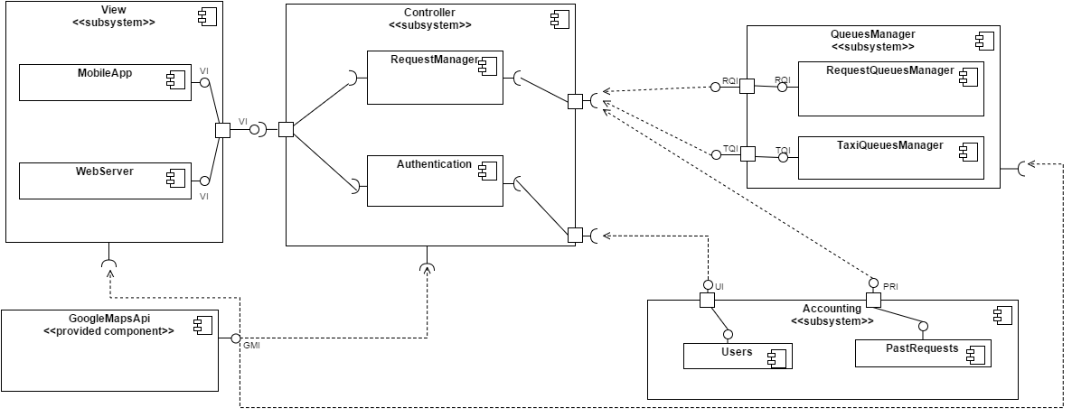

See the Design Document

The element to be integrated are the View, with the sub component MobileApp and the Web Server, the Controller, with the sub-component Request Manager and the Authentication, the Queue Manager( Taxi and request Queue Manager) and the Accounting of User and PastRequest.

## 2.3 Integration Testing Strategy

We decided to use a **TOP-DOWN** strategy giving priority to risky modules. We applied this pattern, because we think that it is better to test problematic interactions first, in order to find big problems as soon as possible. In our system the hardest interactions are the ones between components of the controller subsystem and the ones between the Controller and the Queue Manager. TOP-DOWN integration starts from the components that has the highest number of “use” or “include” relation, so in our case from the Controller’s ones. So applying TOP-DOWN strategy the riskiest interactions will be tested first.

The following diagram shows the levels of interactions. The hardest ones are highlighted using thicker lines:

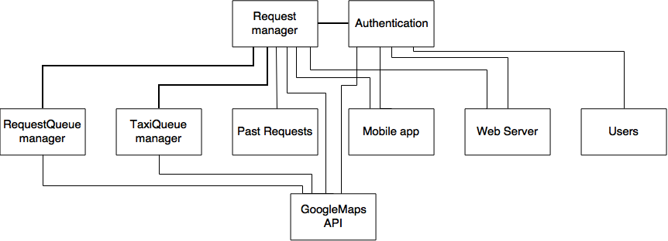

## 2.4 Sequence of Component

Related to the section 2.3 where we had choose the bottom up strategy for the integration of the component.

### 2.4.1 Software Integration Sequence

#### Diagram:

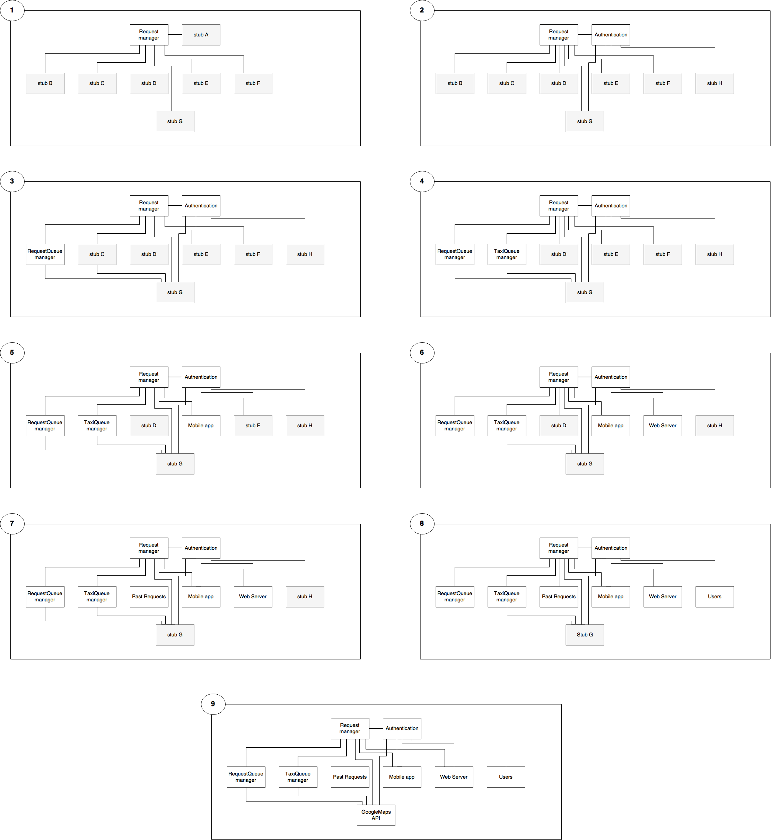

#### Table:

|  |  |  |  |
| --- | --- | --- | --- |
| ID | Integration test | | Paragraphs |
| I1 | RequestManager 🡪 Authentication | | 3.1 |
| I2 | RequestManager 🡪 RequestQueueManager | | 3.2 |
| I3 | RequestManager 🡪 TaxiQueueManager | | 3.3 |
| I4 | RequestManager, Authentication 🡪 MobileApp | | 3.4 |
| I5 | RequestManager, Authentication 🡪 WebServer | | 3.5 |
| I6 | RequestManager 🡪 PastRequest | | 3.6 |
| I7 | Authentication 🡪 Users | | 3.7 |
| I8 | RequestManager, Authentication,  RequestQueueManager, TaxiQueueManager | 🡪 GoogleMapsAPI | 3.8 |

# 3. Individual Steps and Test Description

## 3.1 Integration test case I1

|  |  |
| --- | --- |
| Test Case Identifier | I1T1 |
| Test Item(s) | RequestManager 🡪 Authentication |
| Input Specification | Create typical RequestManager input |
| Output Specification | Check if the correct methods are called in the Authentication |
| Environmental Needs | Mobile app, WebServer, GoogleMapsApi, Users, PastRequest, RequestQueueManager, TaxiQueuesManager Stubs |

## 3.2 Integration test case I2

|  |  |
| --- | --- |
| Test Case Identifier | I2T1 |
| Test Item(s) | RequestManager 🡪 RequestQueueManager |
| Input Specification | Create typical RequestManager input |
| Output Specification | Check if the correct methods are called in the RequestQueueManager |
| Environmental Needs | I1 Succeeded and Mobile app, WebServer, GoogleMapsApi, Users, PastRequest, TaxiQueuesManager Stubs |

## 3.3 Integration test case I3

|  |  |
| --- | --- |
| Test Case Identifier | I3T1 |
| Test Item(s) | RequestManager 🡪 TaxiQueueManager |
| Input Specification | Create typical RequestManager input |
| Output Specification | Check if the correct methods are called in the TaxiQueueManager |
| Environmental Needs | I2 Succeeded and Mobile app, WebServer, GoogleMapsApi, Users, PastRequest Stubs |

## 3.4 Integration test case I4

|  |  |
| --- | --- |
| Test Case Identifier | I4T1 |
| Test Item(s) | RequestManager 🡪 MobileApp |
| Input Specification | Create typical RequestManager input |
| Output Specification | Check if the correct methods are called in the MobileApp |
| Environmental Needs | I3 Succeeded and WebServer, GoogleMapsApi, Users, PastRequest Stubs |

|  |  |
| --- | --- |
| Test Case Identifier | I4T2 |
| Test Item(s) | Authentication 🡪 MobileApp |
| Input Specification | Create typical Authentication input |
| Output Specification | Check if the correct methods are called in the MobileApp |
| Environmental Needs | I1 Succeeded and WebServer, GoogleMapsApi, Users, PastRequest Stubs |

## 3.5 Integration test case I5

|  |  |
| --- | --- |
| Test Case Identifier | I5T1 |
| Test Item(s) | RequestManager 🡪 WebServer |
| Input Specification | Create typical RequestManager input |
| Output Specification | Check if the correct methods are called in the WebServer |
| Environmental Needs | I3 Succeeded and WebServer, GoogleMapsApi, Users, PastRequest Stubs |

|  |  |
| --- | --- |
| Test Case Identifier | I5T2 |
| Test Item(s) | Authentication 🡪 WebServer |
| Input Specification | Create typical Authentication input |
| Output Specification | Check if the correct methods are called in the WebServer |
| Environmental Needs | I1 Succeeded and GoogleMapsApi, Users, PastRequest Stubs |

## 3.6 Integration test case I6

|  |  |
| --- | --- |
| Test Case Identifier | I6T1 |
| Test Item(s) | RequestManager 🡪 PastRequest |
| Input Specification | Create typical RequestManager input |
| Output Specification | Check if the correct methods are called in PastRequests |
| Environmental Needs | Users and GoogleMapsAPI stubs and I5 succeeded |

## 3.7 Integration test case I7

|  |  |
| --- | --- |
| Test Case Identifier | I7T1 |
| Test Item(s) | Authentication 🡪 Users |
| Input Specification | Create typical Authentication input |
| Output Specification | Check if the correct methods are called in the Users |
| Environmental Needs | GoogleMapsAPI stub and I6 succeeded |

## 3.8 Integration test case I8

|  |  |
| --- | --- |
| Test Case Identifier | I8T1 |
| Test Item(s) | RequestManager 🡪 GoogleMapsAPI |
| Input Specification | Create typical RequestManager input |
| Output Specification | Check if the correct methods are called in the GoogleMapsAPI |
| Environmental Needs | I7 succeeded |

|  |  |
| --- | --- |
| Test Case Identifier | I8T2 |
| Test Item(s) | Authentication 🡪 GoogleMapsAPI |
| Input Specification | Create typical Authentication input |
| Output Specification | Check if the correct methods are called by the GoogleMapsAPI |
| Environmental Needs | I7 succeeded |

|  |  |
| --- | --- |
| Test Case Identifier | I8T3 |
| Test Item(s) | RequestQueueManager 🡪 GoogleMapsAPI |
| Input Specification | Create typical RequestQueueManager input |
| Output Specification | Check if the correct methods are called by the GoogleMapsAPI |
| Environmental Needs | I7 succeeded |

|  |  |
| --- | --- |
| Test Case Identifier | I8T1 |
| Test Item(s) | TaxiQueueManager 🡪 GoogleMapsAPI |
| Input Specification | Create typical TaxiQueueManager input |
| Output Specification | Check if the correct methods are called by the GoogleMapsAPI |
| Environmental Needs | I7 succeeded |

# 4. Tools and Test Equipment Required



A tool used to execute test cases against the container, good for application.

We can use this tool, for example, to take the test for the interact with the Database:

**RequestManager -> PastRequest**

**Authentication-> Users**



A load testing tool for analysing and measuring performance

Perfect for both WebApplication than App, It can be used to simulate a heavy load on a server, network or object to test its strength or to analyse overall performance under different load types.

For our Project, JMeter can set up test plans that simulate logging into our web site, filling out forms, clicking buttons and links.

# 5. Program Stubs and Test Data Required

* **Stub A:** it simulates Authentication behaviour.
* **Stub B:** it simulates RequestQueueManager behaviour.
* **Stub C:** it simulates TaxiQueueManager behaviour.
* **Stub D:** it simulates PastRequests behaviour.
* **Stub E:** it simulates Mobile app behaviour.
* **Stub F:** it simulates Web server behaviour.
* **Stub G:** it simulates Users behaviour.
* **Stub H:** it simulates GoogleMapsAPI behaviour.